Name: Sanika Botre PRN: 25070122063
Batch: 2025-29 Branch: CSE A-2
Subject: Programming with Java

ASSIGNMENT No: 9

TITLE : Write a Java program to demonstrate the use of the final keyword with variables, methods, and classes.

Problem Statement: Write a Java program to demonstrate the use of the final keyword with variables, methods, and classes.

Learning Objectives: To implement the final keyword with variables, methods, and classes.

Theory:

The final keyword restricts modification in Java programs. A final variable cannot be reassigned after initialization. A final method cannot be overridden by subclasses, while a final class cannot be inherited. This improves security, prevents accidental modifications, and increases program reliability. Final is commonly used for constants and immutable classes.

Exercise:

1. Create a Bank Account program where account number is final and cannot be changed.

Code:-

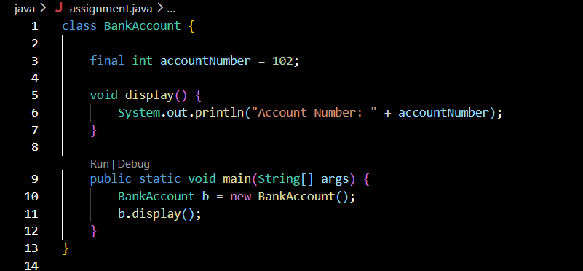

Output:-

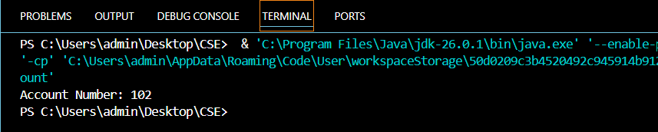

2. Create a Library Book Management program where the book ISBN is declared as final and cannot be changed once assigned. Display the book's ISBN, title, author, and price.

Code:-

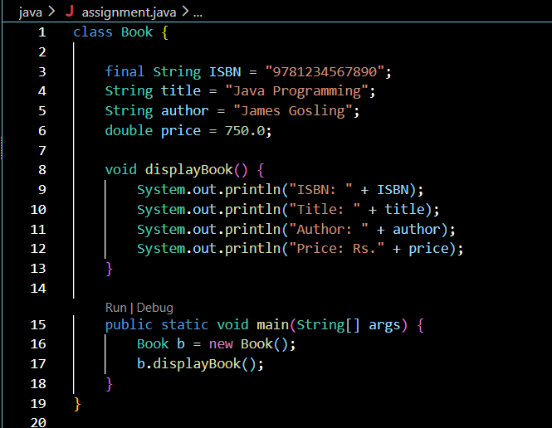

Output:-

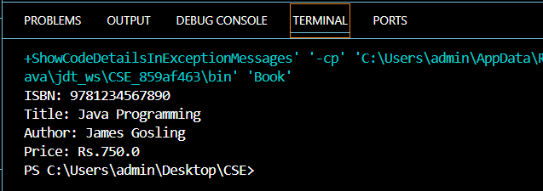

Conclusion:

This assignment successfully demonstrated the use of the final keyword in Java. It showed how final variables can be assigned a value only once, ensuring that their values remain constant throughout the program. The programs executed successfully and highlighted the importance of using final to improve data security and program reliability. Overall, this assignment enhanced the understanding of the final keyword and its role in object-oriented programming.

